12.62: a) The total gravitational potential energy in this model is

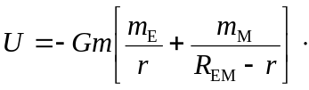
b) See Exercise 12.5. The point where the net gravitational field vanishes is
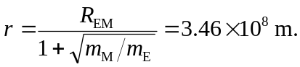
Using this value for r in the expression in part (a) and the work-energy theorem, including the initial potential energy of 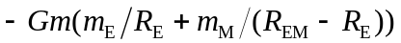 gives 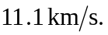 c) The final distance from the earth is not 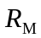, but the Earth-moon distance minus the radius of the moon, or 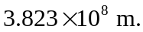From the work-energy theorem, the rocket impacts the moon with a speed of 